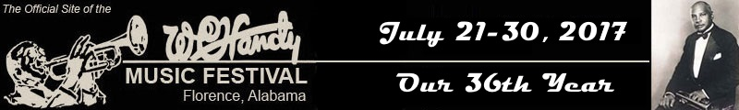

Handy Festival Event TODAY
and it’s right next door (almost!)

Music and Munchin’
in Muscle Shoals

11:30 until 1:30
Wednesday, July 26, 2017
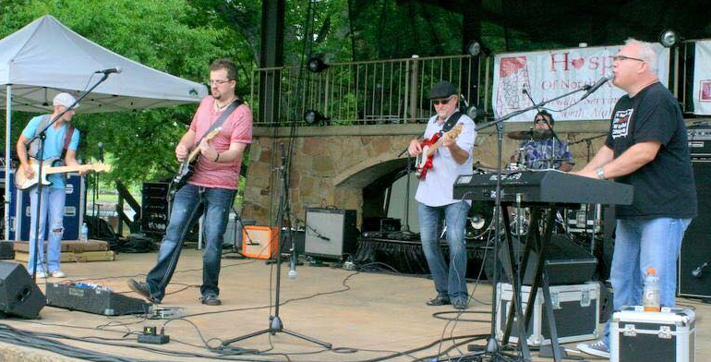
Featuring the music of
a great local group,
C. C. Jags

And… the event is FREE!
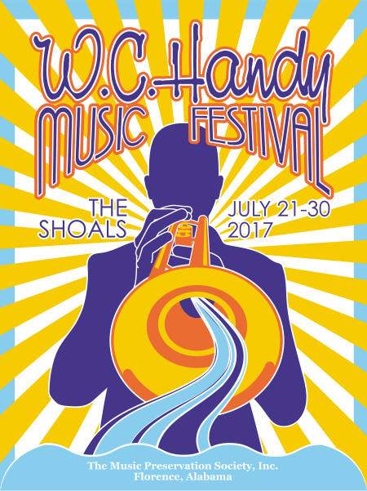
Enjoy lunch here at the center,
then head next door to the
Parks and Recreation Dept Gym #1
and ENJOY THE MUSIC!

Sign up where you sign in for lunch if
you’re going and want us to reserve you a seat!

